F-13
Wireless Mouse
Instructions

Package Contents (attachment)
Mouse x1 receiver x1 Instructions x1

System requirements
IBM or compatible computer
Windows：2000/ME/XP（x64）/Vista/7/8
Mac OS X（over V10.4）
An available USB port

Product Structure Diagram
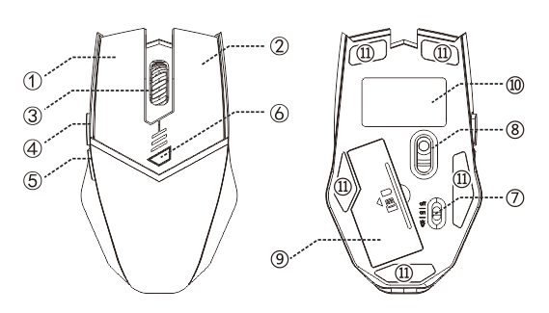

（

Component function description

● ①：Left button ②：Right button ③：Middle button
④：Forward button ⑤：back ⑥：DPI adjustment
⑦：switch ⑧：lens ⑨：Battery compartment, receiver
⑩ ：label ⑾ ：mat

Specification
Button number：6 buttons
Tracking System: optical
Frequency: 2405MHz-2476MHz
Effective distance: 10m
Working voltage/current: 3V/4mA
Button life: 5 million times
Roller life: 1.2 million turn
Product dimensions: 118*70*39mm
Product weight: 95±5g
Resolution: 1000-1600-2400DPI
Rate of return: 250Hz

(Note: The pattern quoted in this manual is only for the purpose of function description. Please refer to the product for purchase.)

What to do if the mouse has no response?
1. According to the positive and negative sign, please install it in the battery box correctly.
2. Please try to replace the receiver with an USB interface.
3. Make sure the power switch on the bottom of the mouse is “on” or at  position.
4. Try to restart the computer.
5. Press the left、middle、right key when the power is on, and put the receiver into the computer, waiting for 5 seconds, and then you could rematch code successfully.
6. If it is still unsuccessful, please email to E-mail: it@zelotes.cn for technical assistance.

