
F-18
Dual-Mode Game Mouse
Wired +2.4G wireless rechargeable appliances

Manufacturer：Shenzhen Master Electronic Technology Co., Ltd.

Package Content（attachments）
mouse x1;receiverx1;instruction;warranty card x1; 1.5M data cable x1

System Requirements
IBM or compatible computer
Windows：2000/ME/XP（x64）/Vista/Windows7/8/10
Mac OS X（above V10.4）
A workable USB interface
1.【Product Function Diagram】
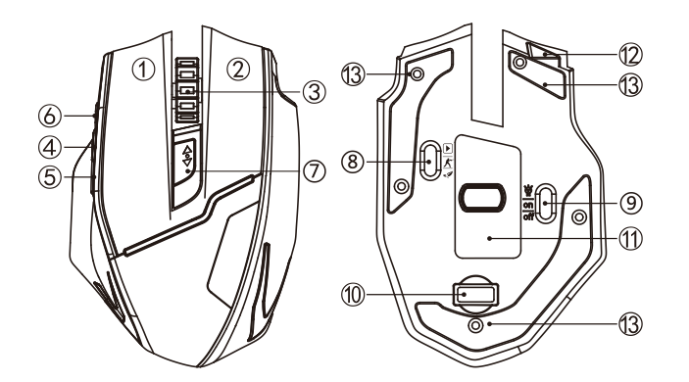

- Default Keys Function and Structure Specification
- ①left mouse ②right mouse ③middle mouse ④forward/previous page
⑤backward/next page ⑥fire mouse button ⑦DPI circle ⑧multimedia
⑨light control ⑩Mini receiver 11optics hole、label 12 data line interface
13 mouse mat、screw hole
2．Multimedia State Corresponding to Buttons Functions（bottom switch move to ）
①left mouse ②right mouse ③volume+- ④video fast-forward
⑤video rewind ⑥play/pause ⑦back to desktop

（Note：Webcasting under the full screen mode）

2.【Product Engineering Parameters】

Basic Parameters
wireless data transmission：1Mbps
frequency：2405MHZ-2476MHZ
channel：32
engine：optics
distance：30m
operating voltage：3V
button life：8 million times
product size：122*82*40mm
product weight：115±5g

Ladder working current：
working current：7mA
standby current：1.3mA
dormant current ：50uA
stateless receiver：10-25uA

Tracking Performance：
resolution：600-1000-1600-2000-2400-3200 DPI
rate of return：250Hz-500Hz
maximum acceleration：20G

3.【Product Features and Instructions】
◎wired + wireless dual-mode rechargeable mouse
Integrated rechargeable battery（non-removable）and 1.5M data line. Charging can be normal used.
◎shortcut thumb function
Fast-forward or fast-backward when browsing the web, the folder under the same window forward or backward function.
◎six speed-change DPI
The DPI design for professional gamer，600-1000-1600-2000-2400-3200 DPI 。7 color circle breathing light design.
◎fire mouse button
Click equal to the 3 times click of the left mouse button.
◎E-sports level 250-500Hz high speed return rate
The rate of return refer to the data transmission speed between mouse and computer, the higher return rate in game can play more mouse performance.250Hz-500Hz return rate for wireless mouse in the game without delay and frame skip which make a practical significance for gamer.
◎three-stage light toggle switch
off: turn off the switch ，on: turn on the switch ，: turn on the breathing light.
◎three-stage multimedia function switch
They aremultimedia/ 500Hz/250Hz。When the switch is in multimedia, the wheel is forward for the volume plus and backward is reduced.PDI button is back to the desktop. Fire mouse button is play/pause. Forward and backward buttons are fast-forward and fast-backward.
4.【Questions】
Number 1：The mouse could not respond？
answer：
- Please change a USB interface for the receiver.
2. Make sure that the power switch at the bottom of mouse has been turned “on” or.
3. Restart your computer.
4.When the mouse is powered on, pressing the left, middle and right button at the same time, inserting the receiver into the computer and 5 seconds latter releasing the button, then re-code success.
Number 2：Does the wireless mouse save power?
answer：
The mouse is used top chip, 5 times more than ordinary wireless mouse power saving. Intelligent three-tier power-saving features. Do not used into a dormant state after 8 minutes and deep sleep half an hour. Power dissipation just 0.0005mA.It is better that turn the bottom switch on 250Hz at work and500Hz in game.
Number 3：Is the mouse unstable when set the mouse reporting rate in 250Hz or 500Hz?
answer：
The improvement of Windows system pointer precision of algorithm does not apply to high rate of return of the mouse. Please follow the steps below to ensure that the mouse is normal used.
1. open-control panel
2. click-mouse
3. enter-pointer options
4. uncheck-improve pointer accuracy

Notes
The mouse uses optics as the mouse movement detection which in accordance with relevant safety regulations.
The mouse uses 2.4GHz radio waves to transmit data. The sight distance is 30 meters. The distance will be reduced with a larger obstacle.
Using on rugged media may affect the use of mouse.
Caution
Change or correction without the approval of the responsible authorities clearly has the right to prohibit the user operating the equipment.
Remarks
The equipment has been tested and comply with the limits of the digital device class B which in accordance with article 15 of the FCC rules. The regulations require reasonable protection against interference at the place of residence. The device will emit radio waves when used. If you do not refer to instructions to install, there may be harmful interference to wireless communication. There is no guarantee that interference will not occur on special equipments. If the device does affect the radio or television reception, it can be turned off to adjust again. The user can exclude interference by one or more of the following methods.
●moving receive antenna；
●Increasing the distance between the device and the receiver；
●Connecting the device to a different circuit with the receiver；
●Consulting a dealer or seeking the help of an experienced wireless/wireless TV technician.

Remind：
The wheel is red when charging and full of electric green.The mouse is plugged in cable can be used as wired and the default rate is 500Hz at this point.

Tip：Tear off the protective cover before use.
Manufacturer：Shenzhen Master Electronic Technology Co., Ltd.
Address：DongGuan city, DongKeng Town, Three high-tech Industrial Park 5, 5th floor
Website：www.zelotes.cn
E-mail：it@zelotes.cn
（Note：The pictures used in the manual are for illustrative purposes only. Please refer to the kind of product！）

